FREELANCE WORK TRACKER
@CREATIVITY THINK (9483175986/7019689991)

ABSTRACT:
The Freelance Work Tracker is a web-based system designed to help freelancers, agencies, and consultants efficiently manage their work hours, tasks, clients, and invoices. The system allows users to log work entries, track time using an integrated timer, manage tasks, and export invoices seamlessly. Administrators can monitor project activity, manage clients, review timesheets, and access dashboard analytics for performance insights. Built using Django and Django Rest Framework on the backend and React with Recharts and pdfkit on the frontend, the platform ensures a structured, reliable, and data-driven workflow for freelance project management..

INTRODUCTION OF THE PROJECT:
Freelancers and small agencies often face challenges in maintaining accurate records of completed work, managing multiple clients, tracking time, and generating invoices. Manual tracking methods are prone to errors, inconsistencies, and inefficiency. The Freelance Work Tracker offers a centralized and automated system that simplifies work logging, task assignment, invoice creation, and analytical reporting. This solution enhances productivity, ensures transparency with clients, and improves financial management through structured invoice exports and dashboard analytics..

PROJECT OBJECTIVES:

• Provide a centralized platform for logging work activities
• Offer a timer-based system for accurate time tracking
• Enable users to assign, view, and manage tasks
• Generate professional invoices using pdfkit
• Provide dashboard analytics for performance insights
• Allow administrators to manage clients and timesheets
• Ensure secure and structured data management
• Support freelancers with detailed reporting and export tools

PROBLEM OF THE STATEMENT:
Freelancers often struggle to maintain consistent records of work hours, task completion, and billing activities. Manual spreadsheets and basic notes result in data loss, incorrect billing, and inefficiency in reporting. Agencies also encounter difficulties managing multiple clients and monitoring team progress. The Freelance Work Tracker addresses these challenges by automating work logging, integrating time tracking, providing structured invoices, and offering dashboard analytics. This ensures accuracy, transparency, and streamlined workflow management for freelancers and client-facing teams..

MOTIVATION OF THE PROJECT:
• To simplify and automate freelance work management
• To minimize errors in timesheet and invoice handling
• To support freelancers with accurate time tracking
• To improve client communication through transparent reports
• To provide dashboards for visual representation of work progress
• To enhance professionalism through system-generated invoices

BLOCK DAIGRAM OF PROJECT:

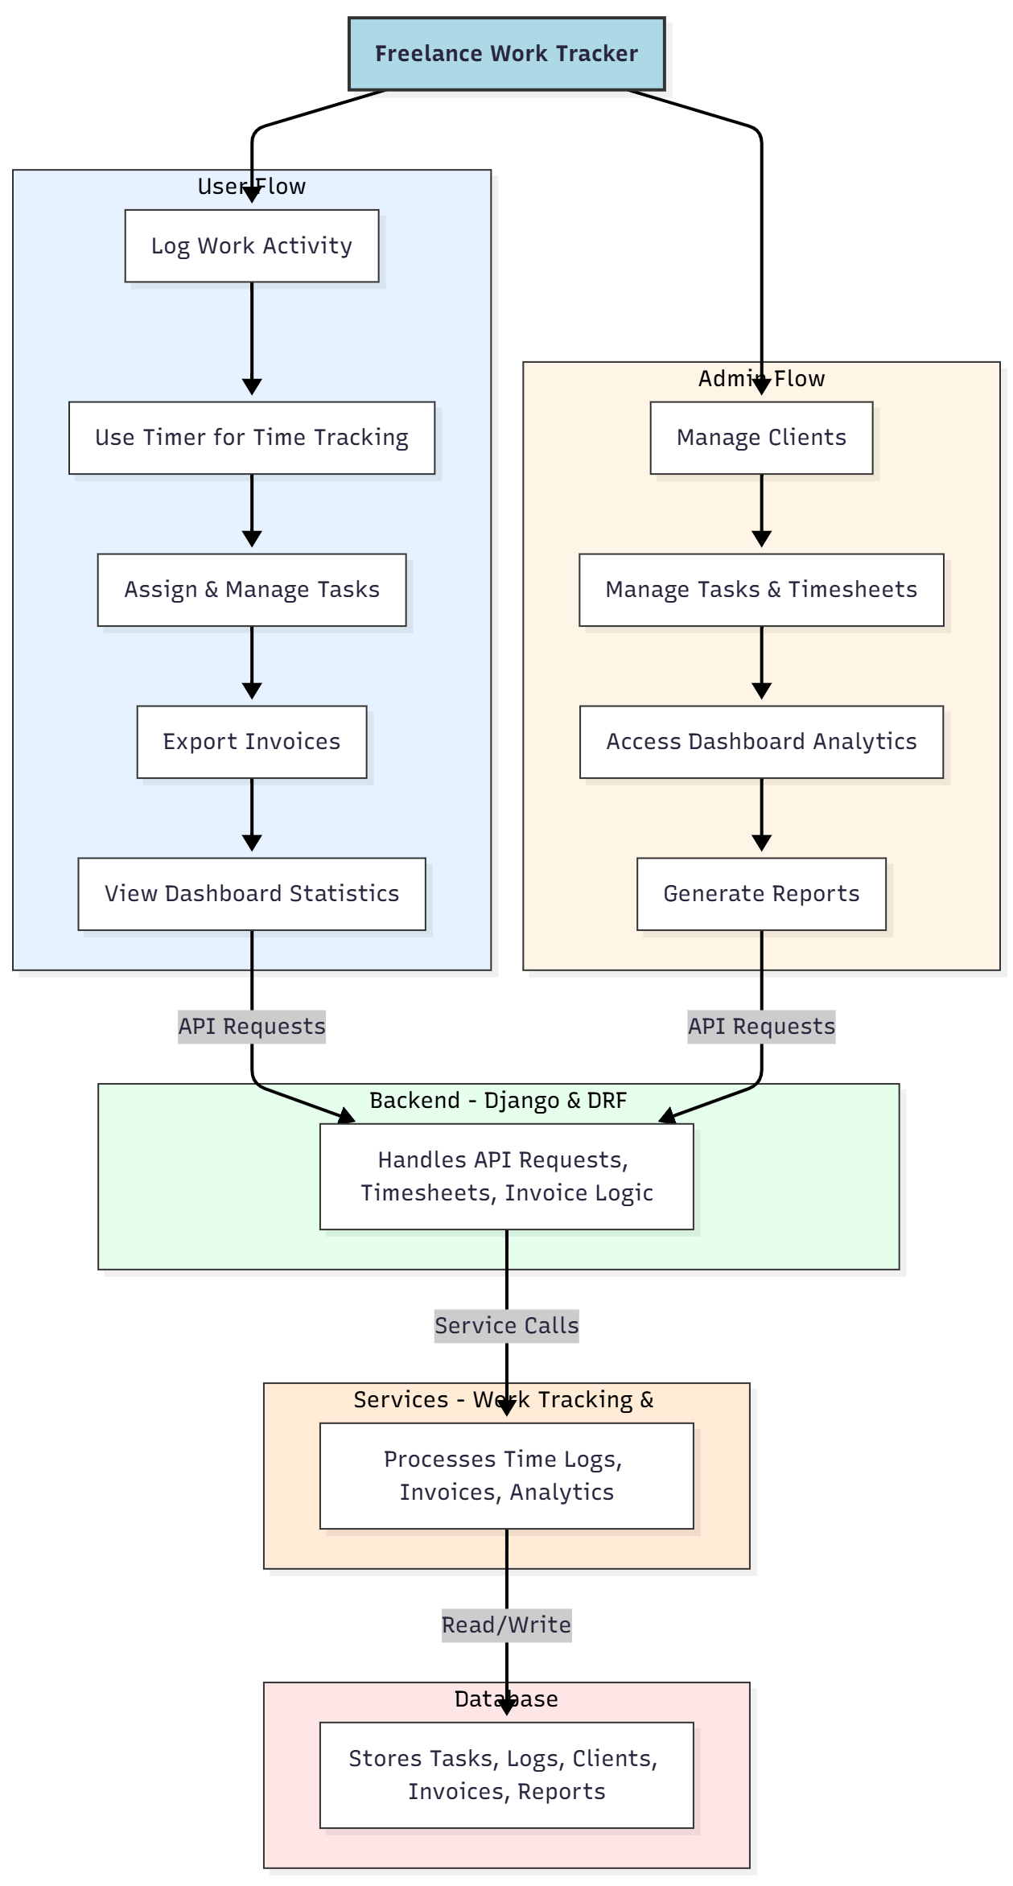

WORKING OF THE PROJECT:
The system begins when a user logs work activity or starts the timer for real-time tracking. Each activity is recorded by the backend, stored securely, and linked with the relevant task or client. Users can assign tasks, monitor their progress, and generate invoices automatically using stored logs. The admin panel allows administrators to manage clients, verify timesheets, and analyze productivity through dashboard statistics. The reporting service processes analytics and prepares invoices, summaries, and charts for export. This streamlined workflow ensures efficient freelance task management and billing..

SOFTWARE REQUIREMENT:
- Backend:
  - Python 3.x
  - Django
  - Django REST Framework
  - SQLite/PostgreSQL
- Frontend:
  - Node.js and npm
  - React.js
  - Axios
- Development Tools:
  - Visual Studio Code
  - Postman (for testing APIs)
  - Git/GitHub (for version control)
- Server/Deployment (Optional):
  - Gunicorn, Nginx, or Heroku/AWS for hosting

ADVANTAGES OF THE PROJECT:

• Automates time tracking and work logging
• Generates clean, professional invoices instantly
• Enhances communication with clients through transparent logs
• Provides detailed analytics on productivity
• Reduces manual work for freelancers
• Supports structured reporting for agencies
• Stores complete work history securely
• Offers a dashboard for clearer insight into workload and earnings

APPLICATIONS OF THE PROJECT:
• Freelancers (designers, developers, writers, etc.)
• Digital marketing agencies
• Consultancy firms
• Project-based companies
• Remote teams
• Small businesses managing multiple clients
• Outsourcing firms
• Virtual assistants and task managers

REFERENCES:

- Django REST Framework Documentation — Django Software Foundation. Django Documentation. Available: https://docs.djangoproject.com/
- Django REST Framework. DRF Documentation. Available: https://www.django-rest-framework.org/
- React. React Official Documentation. Available: https://reactjs.org/docs/getting-started.html
- Redux. Redux Documentation. Available: https://redux.js.org/introduction/getting-started
- PostgreSQL Global Development Group. PostgreSQL Documentation. Available: https://www.postgresql.org/docs/
- MySQL. MySQL Reference Manual. Available: https://dev.mysql.com/doc/
- Git. Git Documentation. Available: https://git-scm.com/doc
- Node.js. Node.js Documentation. Available: https://nodejs.org/en/docs/
- Axios. Axios Documentation. Available: https://axios-http.com/docs/intro
- Socket.io Documentation – https://socket.io/docs/

